Occupational health and safety – environmental protection – data

protection – site safety Applicable to orders placed by
Rolls-Royce Power Systems AG and
Rolls-Royce Solutions GmbH (hereinafter also referred to as "RRS")
at Friedrichshafen premises and to RRS branch offices

Contents
Occupational health and safety – environmental protection – data
protection – site safety Applicable to orders placed by Rolls-Royce Power Systems AG and Rolls-Royce Solutions GmbH (hereinafter also referred to as "RRS") at Friedrichshafen premises and to RRS branch offices
1 General safety notes
2 What to do in the event of fire / emergency / accident
3 Site security
4 Unit testing
5 Construction and assembly work
6 Work equipment
7 Electrical safety
8 Handling hazardous goods and working material
9 Working with asbestos
10 Water pollution control – waste disposal
11 Hot works – explosion prevention
12 Radiation protection
13 Personal Protective Equipment (PPE)
14 Works traffic – cranes – elevators
15 Questions regarding occupational health and safety and environmental protection
16 Data protection and information security
17 Non-compliance with these requirements
18 Subject matter of the agreement
19 Branch offices
20 Annex 1 (confirmation of the Safety Requirements for Outside Companies)
21 Annex 2 (our life-saving rules)

These Safety Requirements are an integral part of the Standard Terms and Conditions of Purchase of Rolls-Royce Power Systems AG and Rolls-Royce Solutions GmbH.

General safety notes

1.1   | Our company places great importance on occupational health and safety, fire protection, data protection, environmental protection and site safety. Contractors and their subcontractors (hereinafter referred to  as "Contractor" or "Contractors") must comply strictly with applicable statutory, government authority and accident insurers' rules and regulations and RRS requirements which are of relevance to fulfilling their remit. Contractors are obliged to ensure health and safety in all activities initiated by them.  Contractors must produce a risk assessment for their employees. A dynamic risk assessment must be produced for non-customary works, new hazards, and when work is being performed for the first time. The Customer must brief the Contractor regarding the on-site hazards. Furthermore, Contractors are obligated to instruct their employees on a regular basis. These documents must be submitted on request.
1.2  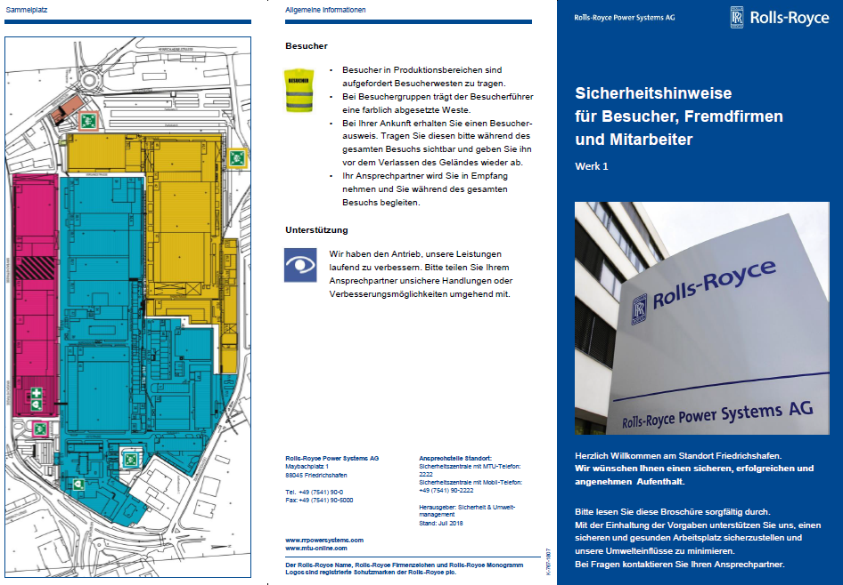 | The instructions on the safety flyer for the site in question, specifically on what to do in the event of an emergency (e.g. fire, assembly points, environmental risk), must be strictly observed. This flyer can be obtained at Reception. When working at other sites/branch offices, Contractors must acquaint themselves with the locally applicable contingency plans well in advance. Instructions issued by security staff (factory security service, factory fire department or general security service) must be followed.
1.3   | The Coordinator (Customer) is the point of contact named on the order. The outside company's  person-in-charge designated by the Contractor must inform their co-workers of these requirements.  If the Contractor hires subcontractors, the Customer must be informed of this. Their supervisors remain responsible for the employees who report to them.  Pursuant to his/her appointment, the Contractor Coordinator also has authority over your employees  who are involved in the work at our premises, if this is necessary to ensure safe working procedures.  It is therefore necessary to follow the Contractor Coordinator's instructions.
1.4 | The Coordinator coordinates any work with the outside company's person-in-charge to avoid mutual risks or hazards. The agreed safety measures must be organized by the outside company's person-in-charge. He/she must instruct their co-workers with regard to implementation and compliance. The implementation of the agreed safety measures must be monitored by the outside company's person-in-charge.  Work must be stopped immediately in the event of any anomalies leading to failure to implement or comply with the agreed safety measures.  The Coordinator must be notified in order to define further measures.
1.5 | Work on Sundays and public holidays must be agreed with the Coordinator. It is the Contractor's responsibility to notify the Trade Supervisory Authority of this.
1.6    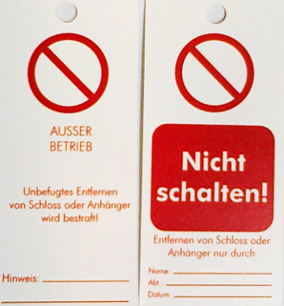   | Work on systems - e.g. machinery, installations, movable or immovable equipment that is live or pressurized - may only be performed if the system is switched off and safeguarded against reactivation (Lockout Tagout). Switching/turning off and re-starts must be agreed with the Coordinator.  Troubleshooting may only be undertaken with utmost care and attention.  Personal locks, locking accessories and signage must be brought along. When working on systems, the hazards presented by live or pressurized media - e.g. hydraulics, hot/cold media, compressed air, gases, spring-loaded parts, gravity, other hazardous materials, etc. - must be taken into account, assessed, and documented.  Any residual energy present must be dissipated safely. Care must be taken to ensure that no energy is able to build up.  A sign stating the name, telephone number and company of the person authorized to turn or switch on the equipment must be affixed to the lock in a clearly legible form.  Where several people are involved, the isolation mechanism must be secured using a multi-point locking system.
1.7   | The use of cell phones is prohibited while driving, going up or down stairs/steps, and operating plant/machinery.
1.8   | Contractors must bring high-visibility vests with them. The affected areas must be pointed out by the Coordinator. High-visibility vests must be worn at all times in loading and transshipment areas.
1.9 | The Customer reserves the right to inspect certificates of competence/qualification.
1.10   | Work under the influence of alcohol or other intoxicating substances is not permitted.
1.11   | Smoking is not permitted within buildings, on roofs, or within energy channels. Smoking is likewise prohibited near gas bottles and in areas marked accordingly, e.g. explosion-hazard areas.
1.12 | Prohibition signs, mandatory instruction signs, and information signs in our factories and plants must be obeyed at all times.
1.13   | Prohibition of wearing headphones and earphones for entertainment. This excludes headphones and earphones worn for hearing protection.

What to do in the event of fire / emergency / accident
2.1  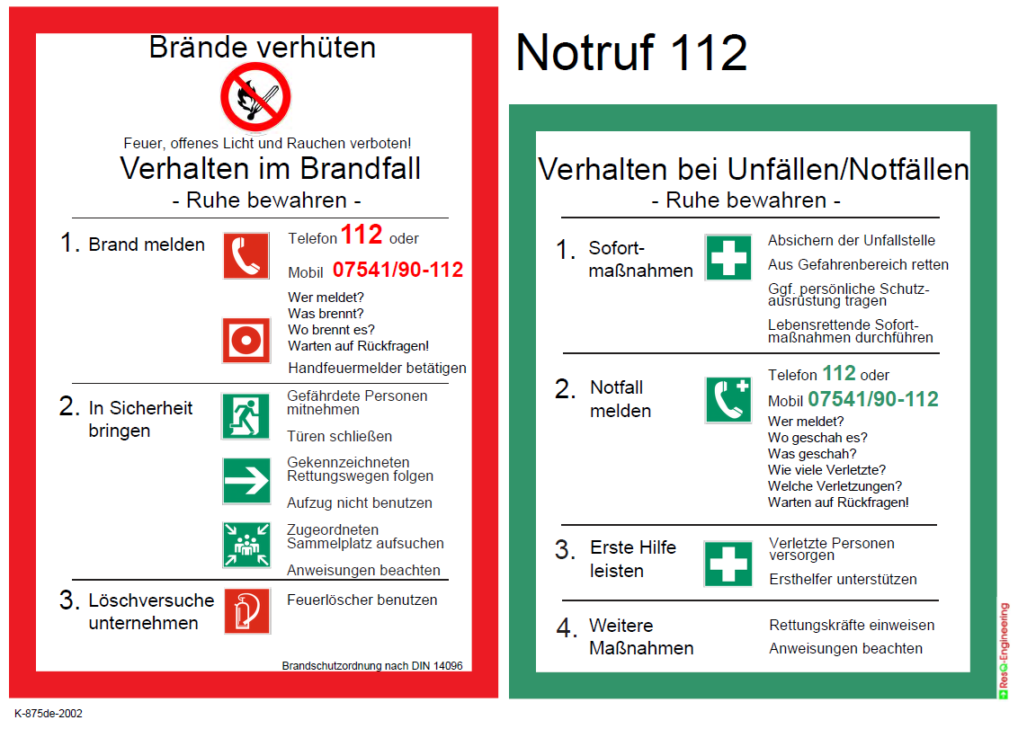  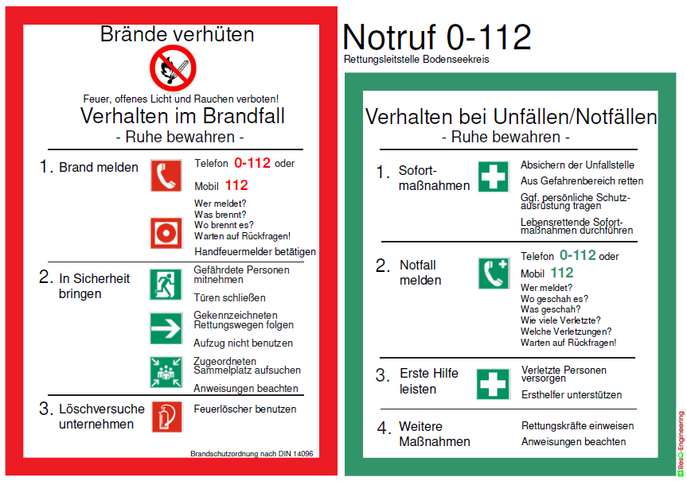 | In the event of fire or emergency (flames, gas leakage, open media) and in the event of serious accidents immediately:  - Plant 1, Plant 2 and Karl-Maybach-Haus (KMH):  RRS's permanently staffed Safety Center: RRS-phone 112 or Mobile 07541/90-112.
- From branch offices: External rescue coordination center RRS-phone 0-112 or Mobile 112. In addition, the on-site security service must be informed.

RRS Safety Center: RRS-phone 2222 or Mobile 07541 90-2222

2.2  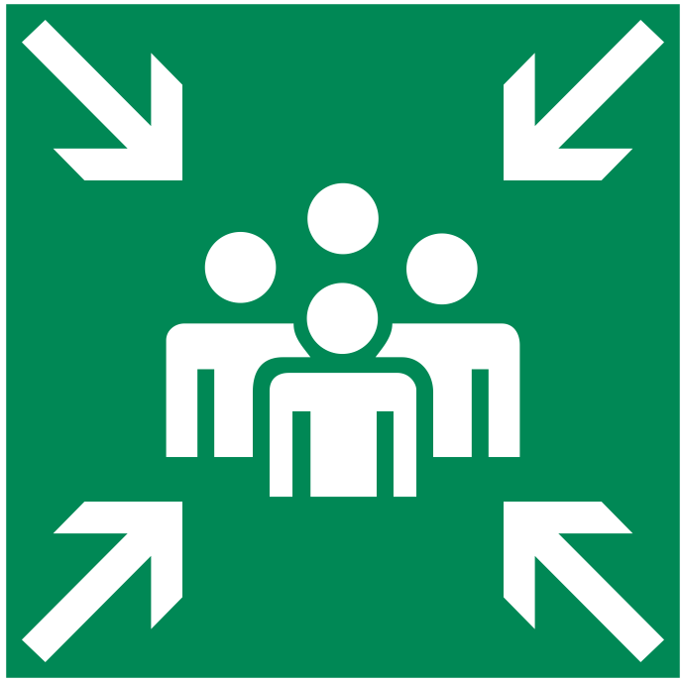 | Fire or gas leakage: Try to extinguish the fire or stop gas leakage, paying attention to your own safety.  Otherwise, immediately make an emergency call and go to the marked assembly point. Wherever possible,  take with you anyone else who may be at risk. Also refer to the information in the safety flyer resp.  fire precaution regulation.
2.3   | In the event of an accident, our company medical service (emergency medical service for Plants 1 and 2) is on hand to provide assistance.  First-aid materials are available for emergency treatment at our sites. Nothing  is allowed to be changed at the accident location, providing this does not interfere with the rescue of personnel.

Site security

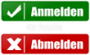  3.1 | On arrival at the site, each of the Contractor's employees must check in personally at Reception. When leaving the site, the Contractor's employees must check out personally. Access to Rolls-Royce Solutions / Rolls-Royce Power Systems AG premises must always be through one and the same gate. Those issued with CONTRACTOR ID tags are exempt from these requirements.  The affiliation of the appointed employees to the outside company in question must be clearly visible  (e.g. company logo on work clothing, CONTRACTOR ID tags or general visitor ID tags). Any vehicles, machines, tools and other equipment (e.g. ladders, scaffolding) must be clearly marked as belonging to the outside company.  The Contractor's employees must remain in the area to which they have been deployed based on the contract agreed with us. Access to other areas of the company premises is strictly forbidden.
3.2   | The Contractor must inform the Coordinator of the commencement of work, work breaks, work carried out outside normal working hours (e.g. in the evening or on Saturdays), and the end of work. In addition, the Coordinator must be advised of potential disruptions to normal operations.
3.3 | To protect property, the site security staff or their appointees are entitled to carry out checks at the gates. When entering or leaving the plant premises, packages, bags and other containers must be presented open when requested to do so. When so requested, the site security staff must be permitted access to vehicles (including the sleeper-cab in trucks) in order to check any items carried on board.
3.4 | The company premises includes security areas to which special regulations apply:  - Specially secured areas have additional mechanical and/or  electronic access control, (this applies to e.g. test stands, engineering departments, site security office, Safety Center, etc.).  - Areas secured with access control terminals may only be entered with the consent of the specialist department and the Coordinator.  - Contractor employees who work in security areas subject to confidentiality will be instructed separately by the RRS Security Officer.  - Some critical areas are subject to higher security requirements but not protected by additional security equipment (such areas include Auditing, Human Resources, etc.).  - If Contractor employees are assigned to work alone in these areas on a regular basis, their names must be communicated to the Coordinator before they start to work there.  - The Contractor must provide a list of their employees, including the employees' names and assigned working areas. The person-in-charge on site must inform RRS Site Security if a Contractor employee will not be appearing for work or is being replaced by another person.  - RRS Site Security is entitled to issue separate instructions to Contractor employees who work in critical areas.  - Due to the importance of the above regulations, reference is made here to Item 17 – Non-compliance with these requirements.
3.5  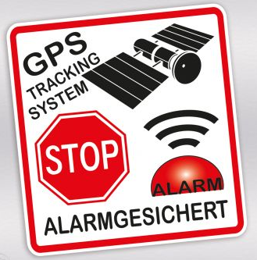 | In the interests of safeguarding the property of Rolls-Royce Solutions GmbH, tools and measuring equipment are fitted with anti-theft protection.
3.6   | It is prohibited to make recordings of plant equipment and working methods.  This also includes a ban on taking photographs. In addition to this, employees from outside companies are obligated to maintain confidentiality toward third parties in respect of the aforementioned matters, even after completion of their work.

Unit testing
 | If a unit has to be put into operation for testing purposes, the Contractor must assess and document  the risks/hazards. Suitable safety and security measures must be taken and agreed with the Coordinator.

Construction and assembly work
5.1   | If the factory/plant fence needs to be opened, this is only possible in consultation with the  Coordinator/Site Security in order to define suitable alternative measures. If a Contractor opens a  factory/plant or site fence, the Contractor must ensure that this is closed again immediately afterwards  so that the factory/plant or site is secured.  Road blocks: To be agreed with the Coordinator/factory security service and factory fire department.
5.2   | Suitable safeguards must be used when working in areas involving a risk of falling.  Roofs: A safety distance of 2 m must be kept from the edge; apart from this, personal protective equipment against falls from a height or a barrier/scaffolding must be used.  Roofs with no load-bearing surface, e.g. glass roofs, corrugated roofs: Risk of fracturing!  Agree safety measures with the Coordinator. Openings in floors, ceilings and roof surfaces as well as cavities or pits on sites must have protective features at all times.
5.3  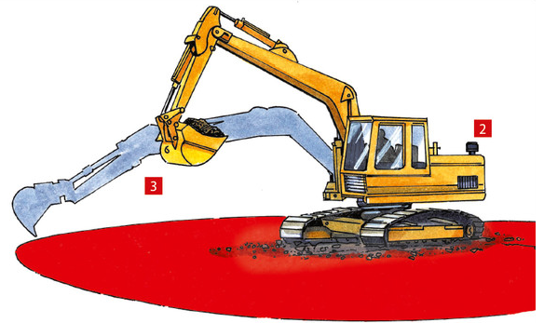 | Civil engineering work (drilling, sawing, excavating etc.) as well as prior to drilling work on buildings:  The Contractor must request information regarding the position of live cables, water and gas lines, etc. from the relevant specialist department via the Coordinator.  The work is approved by the specialist department.
5.4 | Energy channels may only be entered while wearing a protective helmet or protective cap and an emergency light.
5.5 | Working in isolation must be avoided wherever possible. Where it is necessary to work alone, the  Coordinator must be informed of this. Alternative measures are to be planned and implemented by the Contractor.
5.6  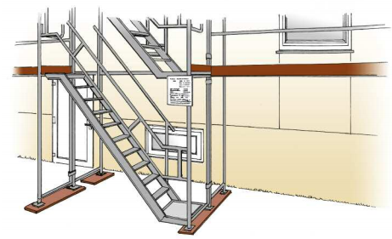 | Scaffolding: The scaffolding contractor (competent/qualified person) must attach a permanently visible approval certificate on the scaffolding. This is the only scaffolding that is allowed to be walked upon.  Changes to scaffolding may only be made by the scaffolding contractor.  Unless completely closed scaffolding is used, work on the scaffolding must not be carried out while work is in progress below. Fully enclosed scaffolding areas are excluded from this requirement.
5.7  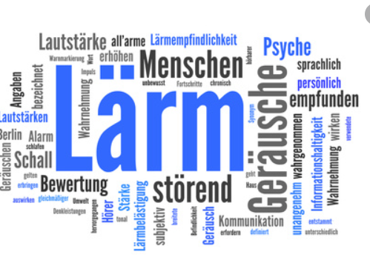 | Extreme noise pollution: Inform the Coordinator in due time in order to define suitable noise protection measures.
5.8  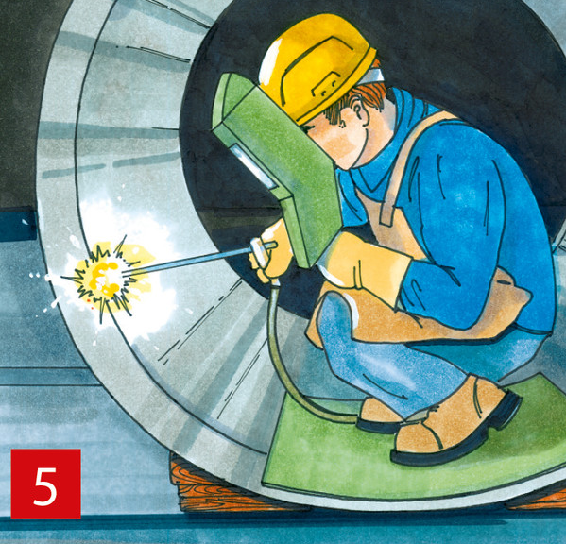 | Prior to working in containers and confined spaces, written approval  (i.e. a permit) must be obtained via the Coordinator.
5.9 | If "site huts" (daytime shelters, etc.) are to be erected, the Contractor must obtain prior approval from the Coordinator. The legal requirements for such buildings (Workplace Regulations) must be complied with. Connections to plant infrastructure (power, water, etc.) must be requested via the Coordinator.
5.10 | The use of gas-heated or otherwise heated tar boilers is not permitted on roof surfaces.  Fire extinguishers must be kept within easy reach when using tar boilers. Observe the installation instructions!
  5.11  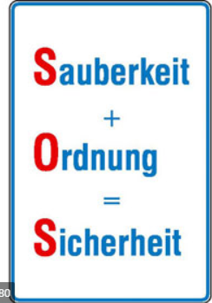 | Ensure tidiness and cleanliness on work/construction sites and in storage areas at all times. For  quality assurance reasons, dust protection walls must be erected or vacuum cleaners must be used  when carrying out work involving dust formation. Dust, foreign material and waste must not be allowed  to enter the RRS production processes!
5.12 | Following completion of work on buildings, plants or machinery, a final check must be carried out jointly with the Customer. Here it must be ensured that all safety-relevant equipment and devices operate correctly again. Leave the workplace in a clean condition.
5.13 | Wall penetrations and the opening of any firewalls must be reported to the Coordinator without delay in order to maintain fire safety standards.
5.14   | Before commencing and after completing work that creates dust or steam/vapors at our premises in  Friedrichshafen, it is necessary to phone the Safety Center with RRS-phone 2222 or Mobile 07541 90-2222. Any smoke detectors in the vicinity must be specified and flagged for inspection. After completing the work, the Contractor must have the smoke detectors re-activated by the Safety Center. Local regulations apply to other sites.  Cf. also Item 11.1 – Hot works – explosion prevention.
5.15  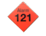 | Before working on installations with an alarm connected to the Safety Center (red hash followed by the alarm number), the go-ahead must be obtained from the Coordinator.  Local regulations apply to other sites.
5.16  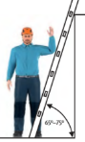 | Work up ladders may only be carried out if the working area around the ladder is cordoned off, and the ladder is standing securely on firm, level ground. No work involving high levels of physical effort may  be carried out up ladders. People working up ladders are not allowed to lean outwards. Other statutory regulations and accident insurance requirements for working with ladders must be observed.

Work equipment
6.1  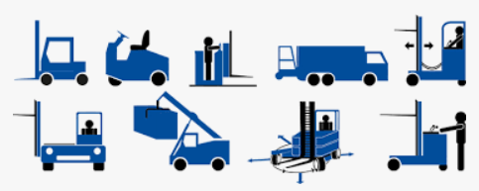 | Use of the Customer's company-owned equipment (machinery, elevating work platforms, cranes,  tools etc.) is only permissible in exceptional cases. Approval is issued by the responsible specialist  department and must be obtained via the Coordinator.
6.2   | Tools, machines and equipment used by the Contractor at our premises must comply with the applicable regulations, ensure operational safety, and have undergone testing. These must be checked visually for defects prior to each use. Tool and equipment defects and damage must be reported to the supervisor immediately. Further use of such tools and equipment is prohibited.
6.3     | Users must receive familiarization training for elevating work platforms before these are entrusted to their care. The operating instructions must be followed (specifically in this instance the instructions for using the emergency descent function).  The requisite personal protective equipment against falls from a height must be worn while using articulated telescopic platforms. A fall arrester certified for use with elevating work platforms must be used. This must also be used when working horizontally. In confined spaces, do not hold onto outside handrails. Wear a helmet or hard hat if necessary. A second familiarized person must be in attendance, who is able to take rescue action in the event of an emergency (e.g. use the emergency descent function). Areas beneath the area being worked upon with elevating work platforms must be cordoned off, allowing for an adequate safety distance.
6.4   | Individual batterie-loading areas for electrically operated industrial trucks or hydraulic/lifting platforms may only be set up and used following consultation with the Coordinator. Maintain the required safety distance from flammable objects (2.5 m) and explosion-prone areas (5 m).
6.5   | The grounding cable of electric welding equipment must be routed to the workplace and secured accordingly to avoid stray currents which might destroy the grounding system of our machinery  and equipment.
6.6   | We are continuously improving our energy efficiency. Help us in this effort and use energy-efficient equipment only. Switch off unused consumers during break times and overnight.
6.7 | The use of direct-acting powder-actuated fastening tools is not permitted. Indirect-acting powder-actuated fastening tools must comply with current requirements and may only be used with the agreement of the Coordinator.

Electrical safety

7.1  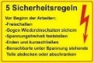 | Before any work on electrical systems/appliances, the 5 safety rules must be observed!
7.2 | Electrical tests according to DGUV regulation 3 and manufacturer's specifications must be applied:  - Before initial commissioning  - Before recommissioning  - After modification/extension  - After conversion  - After repair
7.1  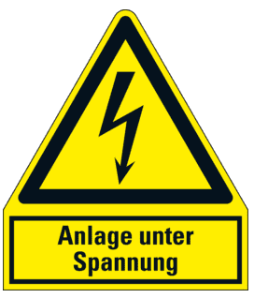  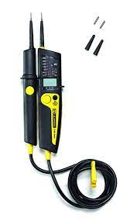 | Working under voltage is not allowed!  If working under voltage is necessary in an emergency, special protective measures must be devised with the Coordinator and the specialist electrical engineering department and then defined in  specific work instructions.  Troubleshooting on electrical systems may be performed under voltage. Depending on the hazard(s) involved, appropriate personal protective equipment shall be worn while such work is being performed. The absence of voltage must be correctly established using a two-pole voltage tester in accordance with the current standard IEC/EN 61243-3; (VDE 0682-401) with at least CAT III resp. CAT IV.  If work needs to be carried out in the vicinity of live installations or equipment, the relevant electrical  engineering department must be informed via the Coordinator, which then decides on the relevant action.  Electrical power shutdowns must be requested well ahead of time to ensure timely agreement and  coordination. Electrical power shutdowns and startups and protection removal and installation must only be carried out following approval from the Coordinator. Any form of activity without permission is prohibited.
7.2 | Permanent electrical connections (without connector) to our plant network are only permissible following approval from the Coordinator.
7.3  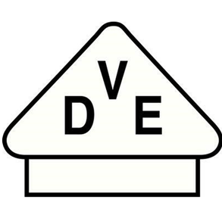 | Safety switches/RCDs must always be used when operating electrical equipment.  Portable residual current devices must be fitted with a protective ground conductor monitoring system (PRCD-S) with a maximum fault current of 30 mA.
7.4   | To ensure fire safety in our plants, use of the following heating devices is prohibited:  - Coffee machines with hotplate (only coffee machines with thermos flask are allowed)  - Single hotplates (only single hotplates with induction surfaces and auto-timeout feature are  allowed)  - Fan heaters by agreement only, and strictly where a verified requirement exists.  The safety regulations concerning the set-up of equipment which generates heat during operation (e.g. heat guns, fan heaters, etc.) must be complied with at all times (maintain safety distance to flammable objects, free air intake, do not place flammable materials on heating devices, do not use flammable bases or underlays).

Handling hazardous goods and working material
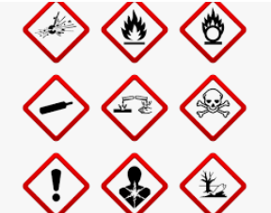 | Only hazardous materials approved by the Customer are allowed to be used.  The Customer is entitled to reject the use of certain hazardous materials.  The use of CMR substances (carcinogenic, mutagenic or toxic to reproduction) is strictly prohibited.  Danger to personnel as a result of the hazardous substances being used, or the hazardous substances arising during work, shall be avoided. If it is necessary to store hazardous goods/compressed-gas cylinders, the storage conditions must be agreed with the Coordinator/ factory fire department and provided in accordance with their instructions.

Working with asbestos
 | When working with materials containing asbestos, specific agreements must be reached  and protective measures must be taken. This work may only be performed by companies and personnel authorized to do so in accordance with TRGS 519 (Technical Rules for Hazardous Substances), depending on the type of work. The Coordinator's prior agreement is required before commencing work on bay/factory floors (drilling, milling, etc.). Important: Magnesite screed may contain asbestos.

Water pollution control – waste disposal
10.1 | Substances hazardous to water must be handled so that no contamination of the soil, ground water or  any body of water is possible. If, due to unforeseeable circumstances, any significant soil or water pollution should occur, the given emergency numbers (see Page 1) and the Coordinator must be notified without delay. In the case of branch offices with public emergency call number, it is also necessary to notify the Safety Center with RRS-phone 2222 or Mobile 07541 90-2222. without delay.
10.2 | The Contractor is responsible for ensuring that any waste is disposed of properly unless  agreements to the contrary exist.

Hot works – explosion prevention
11.1 | Where hot works (e.g. welding, cutting, grinding, shearing, soldering and heating-up) are necessary,  written permission - e.g. a welding permit - must be obtained via the Coordinator before work commences.  Such work must only be started once the signed permit has been issued. The actions stipulated must be complied with before work starts and during the course of the work.  - Prior to as well as after completion of the hot works at our premises in Friedrichshafen, it is necessary to phone the Safety Center with RRS-phone 2222 or Mobile 07541 90-2222.  - Any smoke detectors in the vicinity must be specified and flagged for inspection without fail. After completing the work, the Contractor must have the smoke detectors re-activated by the Safety Center.  - The Contractor is responsible in all respects for fire safety in this area during the period of the work to be undertaken.  - The Contractor must remove any movable flammable objects/materials and dust from the danger zone (10 m radius); if necessary also from adjacent areas.  - Stationary flammable objects must be protected using inflammable materials, e.g. welding blankets. Ceiling, wall and floor openings which lead from the work area to other areas must be covered/sealed using inflammable materials, e.g. welding blankets. Fire extinguishers and welding blankets shall be provided by the Contractor.  - The fire extinguishers and welding blankets must be tested regularly. These must be suitable for the hot works. If the Contractor is unable to take the safety precautions, the Coordinator must be informed without delay so that the necessary arrangements can be made.  - A security guard is generally provided by the Contractor; if work is carried out in areas at risk, this is done in agreement with the factory fire department. There must be a security guard present during the hot works. If the security guard leaves the work area, the work must be stopped while the security guard is absent.  - If there are significant changes of location (room, floor, building) for the activities involving hot works on the site, the Coordinator must request a new welding permit from the factory fire department.  - In the worst-case scenario of a fire occurring, the fire department must be notified without delay by phoning numbers on page 1.  - Local regulations apply to other sites.
11.2 | Transportable autogenous welding equipment must be equipped with a suitable fire extinguisher and a proper flash arrestor. All compressed-gas cylinders shall be put away outside of buildings after work each day (unless agreed otherwise after consultation with the factory fire department).
11.3 | Before commencing hot works, the Contractor must be familiar with the emergency precautions and inform their employees working at the plant accordingly. In the event of a fire, the factory fire department / rescue coordination center must be notified without delay, and suitable fire extinguishing measures must be initiated.
11.4   | Explosive areas/installations may only be entered following approval from the Coordinator. All work (cleaning, troubleshooting, maintenance, installation, etc.) must be applied for before prior to the start of work and may only be carried out following approval from the Coordinator. Combustible materials and sources of ignition must be kept well away from these areas/installations. The actions stipulated on the permit must be implemented before work starts and during the course of the work. After completion of the work, all on-site monitoring devices must be reactivated. Local regulations apply to other sites.

Radiation protection
12.1  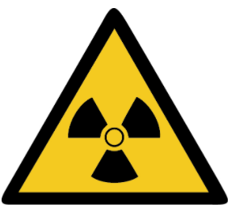 | The following rules apply to the demonstration, commissioning and operation of X-ray equipment and  stray-radiation devices, and to the handling of radioactive materials if a notification or approval is required in accordance with StrlSchG (German Radiation Protection Act) or StrlSchV (German Radiation Protection Ordinance):  Prior to order confirmation, the Contractor must contact the Customer's Radiation Protection Officer (RPO) to notify the RPO of the envisaged radiation protection-related activities plus any radioactive  materials involved. RPO contact details can be provided by the specialist department "Safety & Environmental Management".
12.2 | Contractors must consult with the RPO to agree the radiation safety measures and the timing and  implementation of the relevant activities, and present the documents required for the activities  (approvals, qualification certificates, etc.).
12.3 | Unless express written approval is obtained from the RPO, Contractors on the RRS business premises  are not allowed to perform any work connected to ionizing radiation; the same applies to carrying  and bringing radioactive materials onto RRS business premises. The RPO must inform the Coordinator of all agreements arranged with the Contractor relating to radiation protection.

Personal Protective Equipment (PPE)
13.1  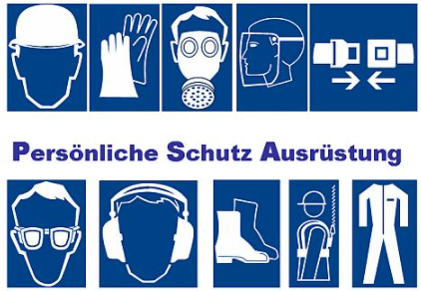 | Contractors must provide their employees with suitable personal protective equipment (PPE). Contractors and their employees are under obligation to wear the protective equipment required for the workplace. Safety shoes must be worn in production areas.
13.2 | When working on test stands, safety shoes, protective goggles and, if required, protective gloves  must be worn. Prior to commencing the work, written approval (i.e. a permit) must be obtained  via the Coordinator.

Works traffic – cranes – elevators
14.1     | The traffic regulations applicable within our plants correspond mutatis mutandis to the German Highway Code. The speed limit in force on our company premises is to be obeyed. Vehicles must be parked in the allocated parking spaces if a vehicle-entry permit is issued. The parking permit must be positioned visibly.  Private vehicles must not be parked on company premises. Non-compliance with these regulations will  result in a €15 fine; repeated non-compliance will lead to the permit to enter the premises by vehicle being withdrawn.
14.2   | Vehicles used on company premises, as well as cranes and elevating work platforms, shall only be driven/operated by persons who have been duly authorized by the Contractor in writing. They must have received appropriate training and have proven their ability to drive. The driving permit shall be carried and produced upon request. Passengers are not allowed to ride on vehicles without available seating.
 | Industrial trucks of category 2 must be equipped with an optical warning device ("Blue Spot" - creates a  blue light spot on the ground in front of the vehicle in the direction of travel).  A retrofit kit or "Blue Spot" with battery is available from the Facility & Object Management  Department.
14.3  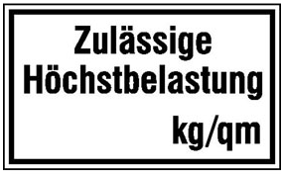   | When using stacker trucks inside buildings, the permitted load-bearing weight of bay/factory floors must be complied with. This is indicated on prohibition signs on the external doors of the bay/factory. For other vehicles such as elevating work platforms, the maximum load-bearing weight of the floor must be obtained via the Coordinator and must be complied with (N.B.: differing wheel loads in the case of articulated telescopic platforms). Driving inside buildings with passenger vehicles or trucks is prohibited (exceptions must be agreed with the Coordinator). The maximum speed limit within buildings is 10 kilometers per hour. Cargo-carrying scooters may not be used.
14.4  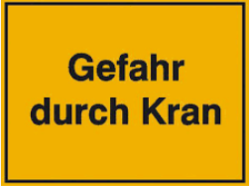 | When working in the operating range of cranes, the Coordinator must be informed about the type and scope of work being carried out. The Coordinator is responsible for approving the work to be carried out. Any such work may only be started following safeguarding of the work site in agreement with the relevant specialist department (e.g. locking of the crane main switch, mechanical limit stops).
14.5   | All passenger elevators are equipped with an intercom system linked to the continuously staffed  Safety Center. In an emergency, the alarm button must be pressed for at least 3 seconds.’  The Safety Center staff will then issue instructions concerning what to do and the next steps. Passenger elevators without landing doors are equipped with a safety light barrier to avoid crushing and trapping of people and transported items.  Particular care must be taken during operation:  - People must stay clear of the elevator shaft walls  - Transported items must be kept clear of the elevator shaft walls  - Secure transported items to prevent them rolling away  - Do not transport items which are longer than the elevator car.  If the safety light barrier is broken during operation, the elevator car control instructions must be followed:  - Remove any obstacles from the safety light barrier  - Press the reset button  - Select floor up or floor down button; elevator slowly moves to next stop.
14.6   | Bicycles may only be used if they are roadworthy, lockable and clearly identified as belonging to the company. A helmet and a high-visibility vest must be worn when riding bicycles.

Questions regarding occupational health and safety and environmental protection
If the Contractor has any questions regarding occupational health and safety or environmental protection, information can be obtained from the Safety & Environmental Management department via the Coordinator. Any such information does not release the Contractor from the responsibilities laid down in the statutory provisions.

Data protection and information security
When working on our premises, Contractors and their employees may have access to sensitive company data or confidential personal information. Contractors and their employees are therefore strictly prohibited from searching cupboards, containers, documents, files, books, indexes, lists, drawings or plans. If Contractors or their employees nevertheless obtain knowledge of the Customer's issues or personal data, any such information must be treated strictly confidentially. Under no account are Contractors allowed to take any data or information carriers.
If the above obligations are violated, Contractors and their employees violating the obligation are liable to pay damages to the contracting company and to those concerned.
Areas secured with access control terminals may only be entered with the consent of the Coordinator. Violations can result in exclusion from the award of contracts.
Information regarding data protection and information security can be obtained via the Coordinator
(refer to Infonet for further information).

Non-compliance with these requirements
If these requirements are violated, we are entitled to expel the persons from our premises without delay and to permanently deny access. Furthermore, we reserve the right to take suitable action in such cases, e.g.:
- termination of the contract with immediate effect
- assertion of further claims.

Subject matter of the agreement
The Contractor carries out a range of work commissioned by Rolls-Royce Solutions GmbH. This gives the Contractor access to the business premises of Rolls-Royce Solutions GmbH. The employed personnel must be referred to the following points of this data protection agreement. The contractual relationship is based on the award of a separate contract. This contract award also includes access to office and business premises of Rolls-Royce Solutions GmbH and the disposal of paper waste, other documents, and files. To dispose of especially large files or folders, the employee concerned may receive a key for a suitable data disposal container. The scope of work must be expressly defined in the work contract, however.
The Contractor expressly refers employees who receive a key for the data disposal container for larger files and folders to the confidentiality requirements and to compliance with the dual-control ('second pair of eyes') principle when opening the container.
The Contractor shall indemnify the Customer against all claims for damages directed against him,
insofar as these are based on a breach of the confidentiality obligations for which he, one of his
employees or one of his vicarious agents is responsible. All confidentiality obligations shall continue to exist, even after the end of the contractual relationship.

Branch offices
 | Regional branch offices located in  Friedrichshafen:  - All branch offices located in  Friedrichshafen  - Überlingen Spare Parts Logistics Center  - Kluftern Materials Management Center  - All off-premises warehouses  - and other newly developed  sites | Nationwide branch offices within Germany:  - Berlin Thyrow  - Cuxhaven  - Duisburg  - Ginsheim-Gustavsburg  - Hamburg  - Leipzig  - Mannheim  - Stuttgart  - Wiesbaden  - Wilhelmshaven  - and other newly-developed sites
Last revised: January 2023

Publisher: Rolls-Royce Solutions GmbH
Specialist department: Safety & Environmental Protection


Annex 1 (confirmation of the Safety Requirements for Outside Companies)
(to be returned to RRS by the outside company together with order confirmation)

Confirmation of the Safety Requirements for Outside Companies by the Contractor

As a Contractor for works and/or services at Rolls-Royce Solutions GmbH, we hereby confirm that we have acknowledged and understood the content of these Safety Requirements for Outside Companies.
We hereby undertake to inform all employees of ours working at Rolls-Royce Solutions GmbH – even if we use subcontractors – about the content of these Safety Requirements for Outside Companies, and to obligate these employees to implement these requirements.

If Rolls-Royce Solutions GmbH specifies further requirements to our responsible employees in the form of oral instructions, we undertake to likewise convey these instructions to all of our affected employees and all affected employees of our subcontractors.

This attestation sheet, fully signed by all employees working on the premises of Rolls-Royce Solutions GmbH must be returned to the Contractor Coordinator at Rolls-Royce Solutions GmbH.

The confirmation is valid for one year.

Company:

Date:

Name:

Signature:

Annex 2 (our life-saving rules)
