Health and Safety – Environmental Protection – Data Protection – Site Security
applicable to work contracted out by Rolls-Royce Power Systems AG and
Rolls-Royce Solutions Augsburg GmbH (SDE-A)
Contents
Health and Safety – Environmental Protection – Data Protection – Site Security
1 General safety precautions
2 What to do in the event of fire/emergency/accident
3 Site safety & security
4 Testing of installations
5 Construction and installation work
6 Tools and equipment
7 Electrical safety
8 Handling hazardous goods and working materials
9 Water pollution control – waste disposal
10 Hot work – explosion safety
11 Personal protective equipment
12 In-plant traffic – cranes – lifts (elevators)
13 Questions about health and safety/environmental protection
14 Data protection and information security
15 Non-compliance with these requirements
16 Subject of the agreement
17 Appendix 1 (Confirmation of Safety and Security Requirements for Outside Contractors)
18 Appendix 2 (Proof of Instruction)
19 Appendix 3 (Our Life-saving Rules)
20 Appendix 4 (Questionnaire Prior to Accessing RRPS Company Grounds)

Call 112
Dasinger Str. 0821-7480-2130

These Safety and Security Requirements are an integral part of the Standard Purchasing Terms of Rolls-Royce Solutions Augsburg GmbH

General safety precautions

1.1   | Our company places great importance on health and safety at work, fire safety, data protection, environmental protection and site security. It is imperative that Contractors and their Subcontractors (hereinafter referred to as Contractors) comply with the applicable statutory, government authority and trade insurance association requirements/regulations and the RRS specifications relevant to the contract concerned. The Contractor shall be obliged to ensure that health and safety requirements are observed in all activities performed at its instigation.  The Contractor is to draw up a risk assessment for its employees. For non-routine work, new hazards and operations being performed for the first time, a dynamic risk assessment is to be produced. The Client shall instruct the Contractor regarding the hazards on site. The Contractor shall also be obliged to regularly instruct its employees. The relevant documents are to be provided on request.
1.2  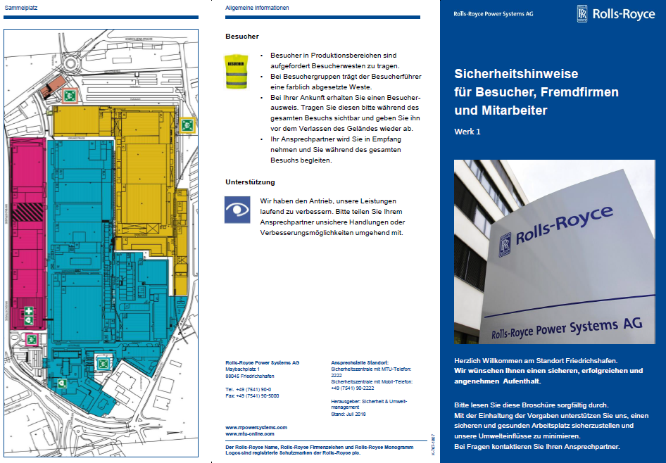 | It is imperative that the guidance notes in the Safety Flyer, specifically regarding what to do in an emergency (e.g. fire, muster points, environmental hazards), are followed. That flyer can be obtained from Reception. It is absolutely essential that the instructions in it are followed.
1.3   | The (Client's) outside-contractor coordinator shall be the person specified as contact on the purchase order. The Contractor's employee responsible as appointed by the outside contractor shall be responsible for instructing the Contractor's employees according to these RRS requirements. Where the Contractor employs subcontractors, the Client is to be informed. Their managers remain responsible for the employees in their charge.  In accordance with his/her terms of appointment, the outside-contractor coordinator also holds directive authority over the Contractor's employees working on our premises where necessary for ensuring safe workingprocedures. The instructions of the outside-contractor coordinator are therefore to be followed.
1.4 | To avoid reciprocal risks, the outside-contractor coordinator coordinates the work with the outside contractor's employee responsible. The agreed safety measures are to be organised by the outside contractor's employee responsible. He/she shall instruct his/her staff regarding implementation and compliance. The implementation of the agreed safety measures shall be monitored by the outside contractor's employee responsible.  In the event of any nonconformities which prevent the agreed safety measures being implemented/complied with, work is to be suspended immediately.  The outside-contractor coordinator must then be informed so that further measures can be defined.
1.5 | Work on Sundays and public holidays must be agreed with the outside-contractor coordinator and is to be reported to the trade regulatory authority (Gewerbeaufsichtsamt). The Contractor bears sole responsibility for such reporting.
1.6    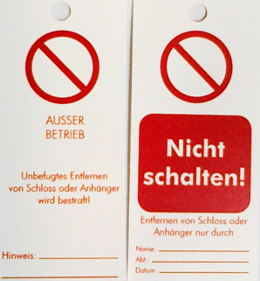   | Work on systems such as plant and machinery, whether static or mobile, which is powered by electricity or pressurised fluids may only be carried out while the plant/machinery concerned is switched off and secured against being switched back on (lock out, tag out). Shutting down and restarting the plant/machinery are to be coordinated with the outside-contractor coordinator.  Troubleshooting may only be carried out with the utmost care and attention.  The employees concerned must bring personally assigned locks, lock tags and signs with them. Where work is carried out on systems, the dangers of electricity and/or pressurised fluids such as hydraulic fluid, hot/cold fluids, compressed air, gas, spring-loaded mechanisms, gravity, hazardous materials, etc. is to be taken into account, assessed and documented.  Any residual energy present must be safely dissipated. Measures are to be taken to ensure that no energy is able to build up.  A clearly legible sign stating the name, telephone number and company of the person authorised to switch the plant/machinery on/off must be attached to the lock.  Where several people are involved, the isolation mechanism must be secured using a multi-lock lockout device.
1.7   | The use of mobile phones/devices is prohibited when driving, walking up and down steps/stairs and when operating plant/machinery.
1.8   | The Contractor's employees must bring with them and wear high-vis vests. The areas concerned shall be made known by the outside-contractor coordinator.
1.9 | The Client reserves the right to inspect proof of qualifications.
1.10 | Working under the influence of alcohol or other intoxicating substances is not permitted.
1.11   | Smoking is strictly forbidden inside buildings, on rooves and energy ducting. Smoking is also prohibited in the vicinity of gas cylinders and in accordingly identified zones such as areas with potentially explosive atmospheres.
1.12 | Prohibition signs, mandatory instruction signs and information signs in our factories and plants must be obeyed at all times.

What to do in the event of fire/emergency/accident

2.1  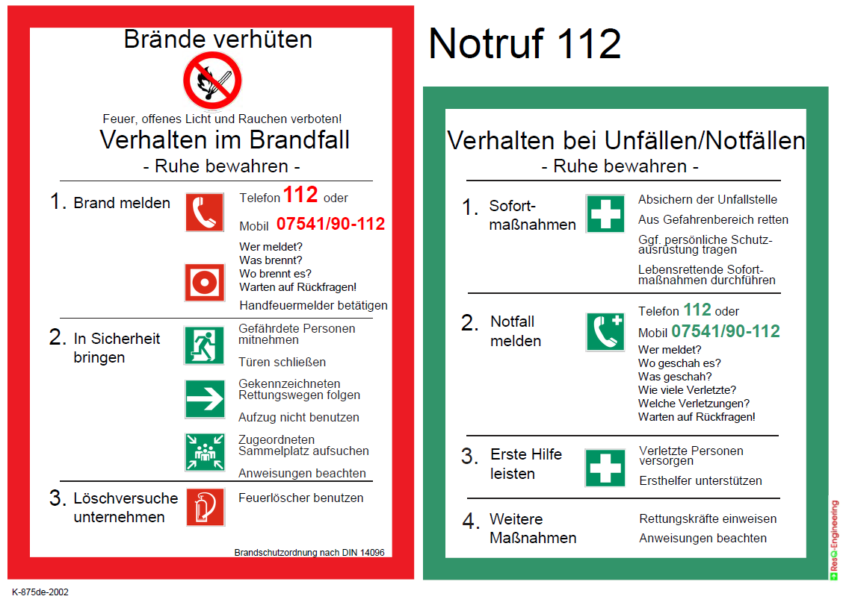  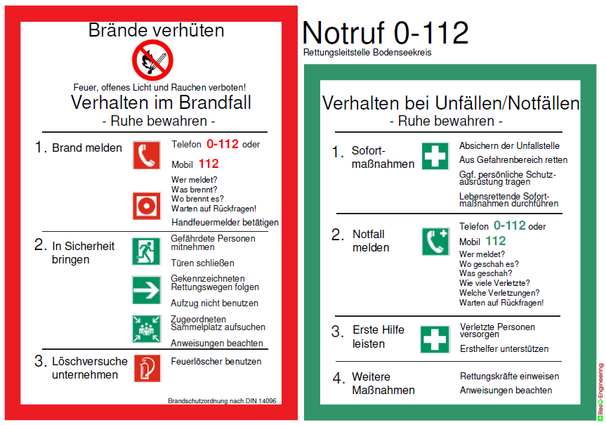 | In the event of a fire or an emergency (fire, escaping gas, fluid spills/leaks) and serious accidents:
- Call 112
- Inform your outside-contractor coordinator

2.2   | Fire or escaping gas: make your way immediately to the marked muster point. Where possible,  take persons in danger with you. See also the information provided in the Safety Flyer.  Attempt to extinguish the fire. Always pay attention to your own safety when doing so.
2.3   | In the event of an accident, our first-aiders are available for assistance.  At our sites, there are first-aid materials available for first-aid treatment and there is also a first-aid room. As far as the rescue of the persons concerned allows, nothing should be changed at the accident site.

Site safety & security
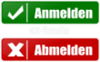  3.1 | Every employee of the Contractor must check in personally at Reception. Similarly, the Contractor's employees must check out personally when leaving the premises. Holders of CONTRACTOR passes (visitor's passes) are exempt from the above rule.  The staff deployed must be clearly identifiable as employees of the outside contractor concerned (e.g. company logo on work clothing, CONTRACTOR passes or general visitor's passes). Any vehicles, tools and equipment, scaffolds, ladders or site accommodation must likewise be clearly identifiable as the property of the outside contractor.  Employees of the Contractor must remain in the area to which they have been asssigned according to the contract agreed with us. Access to other areas of the company premises is strictly forbidden.
3.2   | The Contractor must inform the outside-contractor coordinator of the commencement of work, work interruptions, work outside of normal working hours (e.g. in the evening or on Saturdays) and the completion of work, and advise of any potential disruptions to normal business operations.
3.3 | To protect company property, Site Security or its agents may carry out checks at the company gates. When entering or leaving company grounds, packages, bags and other receptacles must be presented for inspection on request. Site Security must also be given the opportunity on request to inspect vehicles (including the sleeper-cab in trucks) for items being carried.
3.4 | Within the company grounds, there are security-related areas to which special rules apply.  - Specially secured areas have an additional mechanical and/or electronic access lock.  - Access to secured areas is only allowed with the permission of the specialist department and the outside-contractor coordinator.  - Sensitive areas (such as the HR Department, etc.) are subject to a raised level of security-consciousness but are not secured by additional means.  - Contractor's employees who regularly work alone in such areas must be made known to the outside-contractor coordinator in advance.  - The Contractor shall draw up a list of its employees showing the allocation of named staff to working areas. RRS Site Security is to be informed by the Contractor's employee responsible on site whenever Contractor's employees are absent or replaced.  - Contractor's employees who are working in sensitive areas may be required to receive special instruction from RRS Site Security.  - Due to the crucial nature of the above, particular attention is drawn at this point to Section 17 – Non-compliance with these requirements.
3.5   | The recording of plant and equipment and working methods is not permitted.  That includes a ban on photography. Furthermore, the outside contractor's employees shall be obliged  to maintain secrecy regarding the above in their relations with third parties even after completion  of their work.

Testing of installations
If an installation has to be put into operation for testing purposes, the Contractor must assess and document the potential hazards. Suitable security and safety measures must be taken and agreed with the outside-contractor coordinator.

Construction and installation work
5.1   | Making an opening in the perimeter fence is only allowed with the agreement of the outside-contractor coordinator, so that suitable contingency measures can be defined. If a Contractor makes an opening in a factory/site fence, the Contractor must ensure that it is closed up again immediately so that the factory/site remains secure.  Road closures: to be agreed with the outside-contractor coordinator.
5.2   | Suitable safety measures must be taken when working in areas where there is a risk of falling from heights.  Rooves: safe distance of 2m from the edge to be maintained, apart from which fall arrester/safety harness PPE or a barrier/scaffold is required.  Rooves without load-bearing surface, e.g. glass rooves, corrugated-sheet rooves: risk of collapse!  Safety measures to be agreed with the outside-contractor coordinator. Openings in floors, ceilings and roof surfaces, and excavations on construction sites must be secured at all times for the duration of the construction work.
5.3  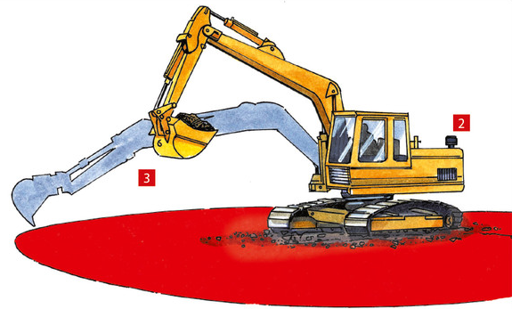 | Groundworks (drilling, cutting, chasing, excavation work, etc.) and drilling and chasing work on buildings: details of the location of electricity cables, water and gas pipes, etc. must be obtained from the specialist department concerned through the outside-contractor coordinator.  The work is to be approved by the specialist department.
5.4 | Situations where employees are working alone should be avoided wherever possible. Where it is necessary for employees to work alone, the details must be reported to the outside-contractor coordinator. Contingency measures must be planned and executed by the Contractor.
5.5  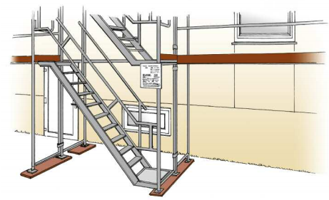 | Scaffolding: approval certificate must be permanently attached in a clearly visible position by the installer (competent person). The only scaffolds which may be used are those that satisfy the above requirements.  Modifications to scaffolds may only be carried out by the scaffolding contractor.  Work should not be carried out from the scaffolding while other work is being carried out below. An exception to the above is allowed in the case of fully enclosed scaffolding.
5.6  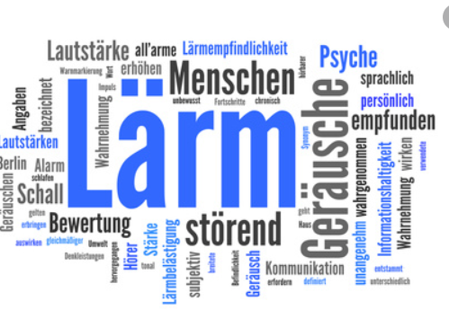 | Especially loud noise levels: outside-contractor coordinator to be informed in time so that suitable noise-limiting measures can be defined.
5.7  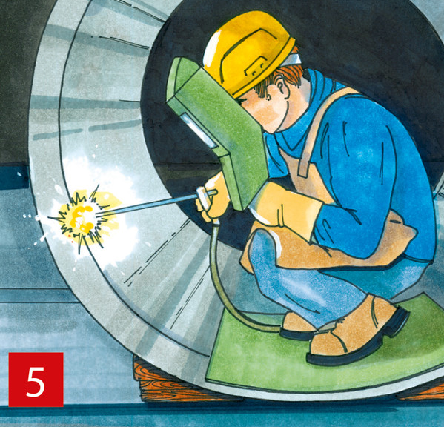 | Before starting work inside containers and confined spaces, written permission must be obtained through the outside-contractor coordinator.
5.8 | If portable site cabins (site accommodation, etc.) are to be erected, the Contractor must obtain permission from the outside-contractor coordinator beforehand. The legal requirements for such buildings (German health and safety regulations) are to be observed. Connections to plant infrastructure (power, water, etc.) must be applied for through the outside-contractor coordinator.
5.9 | The use of gas-fired or otherwise-heated tar boilers is not permitted on roof surfaces.  Fire extinguishers should always be kept within easy reach whenever tar boilers are in use. Observe the installation instructions!
  5.10  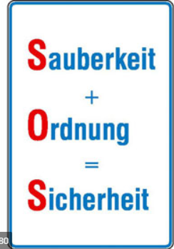 | Work/construction sites and storage areas should be kept clean and tidy at all times. In the case of operations that can generate dust, dust-containment panels should be erected for quality-related reasons  or else vacuum cleaners used. No dust, extraneous material or waste must be allowed into the RRS production processes!
5.11 | Following completion of work on buildings, plant or machinery, a final inspection is to be carried out together with the Client. In the course of that inspection, particular attention must be paid to ensuring that relevant safety-related equipment and installations have been restored to proper working order.  The areas in which work has been carried out must be left in a clean condition.
5.12 | The making of openings in walls and firewalls must be reported immediately to the outside-contractor coordinator so that fire safety can be maintained.
5.13   | Before starting and after finishing work that generates dust or vapour, your outside-contractor coordinator must be informed. Any smoke detectors in the vicinity must be specified and deactivation of them requested. After completion of the work, the Contractor must have the smoke detectors re-activated by the Security Control Room.
5.14 | Before carrying out any work on installations with an alarm connected to the Security Control Room, prior agreement with the outside-contractor coordinator is required.  The relevant local regulations apply at inter-regional sites.
5.15  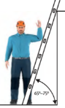 | Working on ladders is only allowed if the work area around the ladder has been cordoned off and the ladder is standing securely on a firm, level surface. No work involving the application of large amounts of force may be carried out on ladders. Persons working on ladders must not lean outwards. Other statutory regulations and trade insurance association requirements for working with ladders must be observed.

Tools and equipment
6.1  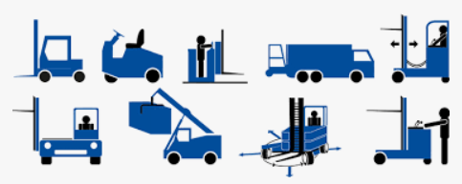 | The use of tools and equipment owned by the Client (machinery, aerial platforms, cranes, tools, etc.) is only permissible in exceptional cases. Such permission is issued by the relevant specialist department and must be obtained through the outside-contractor coordinator.
6.2   | The tools and equipment used by the Contractor on our premises must comply with the current regulations, be in safe and reliable working order and have been tested. They must always be visually checked for defects before use. Staff must immediately report any defective or damaged tools and equipment to their superior.  Continued use of such tools and equipment is prohibited.
6.3     | Users of aerial working platforms must receive instruction before the equipment is handed over. The operating instructions must be followed (specifically in this instance the instructions on emergency lowering).  When using articulated telescopic aerial platforms, the required fall-arrester/safety harness PPE must be worn. A fall-arrester/safety harness certified for use with aerial work platforms must be used. The same must also be used when working horizontally. In confined spaces, do not hold onto the outer handrail; wear safety helmet/hard hat wherever necessary. There must be a second trained person in attendance who can initiate rescue in an emergency (e.g. by operating the emergency lowering function). Areas underneath the area where work is being carried out from an aerial work platform must be cordoned off at a sufficient safe distance.
6.4   | Individual battery charging stations for electric materials-handling trucks/lifting platforms may only be set up and operated in consultation with the outside-contractor coordinator (observe 2.5 m safety clearance from combustible items and 5 m from explosion-risk areas).
6.5   | The earth lead of electric welding equipment must be run into the work area and suitably attached so that stray welding currents that could destroy the earthing system of our machinery and installations are prevented.
6.6   | We are continuously improving our energy efficiency. Please assist us in those efforts by using only energy-efficient equipment. Switch off electrical equipment that is not required during break times, at the end of the working day and overnight.
6.7 | The use of pin drivers is not permitted. Pin drifts must comply with the current requirements and may only be used with the agreement of the outside-contractor coordinator.

Electrical safety
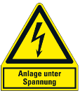  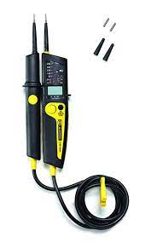  7.1 | Working on live electrical circuits/equipment is not allowed!  Where work on live circuits/equipment is necessary in an emergency, special safety measures are to be worked out in consultation with the outside-contractor coordinator and the Electrical Engineering department and documented in specific job instructions.  Troubleshooting on electrical systems may be performed while the systems are live. For such work the appropriate personal protective equipment according to the level of danger must be worn.  Safe isolation of electrical circuits/equipment must be established using a two-pole voltage tester rated at least CAT III and preferably CAT IV according to the current version of the standard DIN EN 61243-3 (VDE 0682-401).  Where work is to be carried out in the vicinity of plant or equipment that carries electric current,  the relevant electrical engineering department must be involved through the outside-contractor coordinator to decide on the appropriate measures.  Power switch-offs must be applied for in good time. The power supply may only be switched off and back on with the agreement of the outside-contractor coordinator. Performing such operations without authorisation is prohibited.
7.2 | Hard-wired electrical connections (without plug) to our factory mains may only be established with the agreement of the outside-contractor coordinator.
7.3  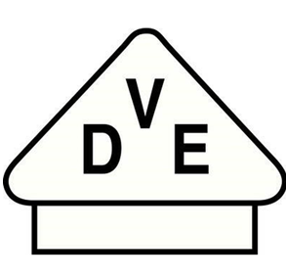 | As a general rule, residual current devices must always be used when operating electrical tools and equipment.  Portable residual current devices must be equipped with a PE monitor (PRCD-S) with a maximum fault current of 30 mA.
7.4   | For fire safety reasons, use of the following types of heating appliance on our premises is prohibited:  - Individual hotplates (only induction-type individual hotplates with timed cutout are allowed),  - Fan heaters by agreement only and subject to verified necessity.  It is imperative that the conditions for setting up heating appliances (e.g. space heaters, fan heaters, etc.) are complied with, e.g. distance from combustible materials, unrestricted air intake, no combustible materials to be placed on heating appliances, combustible materials not to be used as base.

Handling hazardous goods and working materials
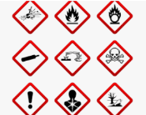 | Only hazardous materials approved by the Client may be used.  The Client shall be entitled to refuse permission for the use of certain hazardous materials. The use of CMR substances (carcinogenic, mutagenic or reprotoxic substances) is strictly prohibited.  Dangers to human health arising from the hazardous substances used or produced in the course of the work must be prevented. Where the storage of hazardous materials/pressurised gas cylinders is necessary, the storage conditions are to be clarified and established in consultation with the outside-contractor coordinator.

Water pollution control – waste disposal
10.1 | Water pollutants must be handled in such a way that no pollution of the soil, the groundwater or watercourses can occur. Should significant pollution of the soil or water occur due to unforeseeable circumstances, the specified emergency numbers (see page 1) and the outside-contractor coordinator are to be notified immediately.
10.2 | The Contractor alone shall be responsible for proper disposal of all accrued waste unless otherwise agreed.

Hot work – explosion safety
11.1 | If hot work (e.g. welding, torch-cutting, grinding, parting, soldering or heating) is required, written authorisation in the form of a welding permit must be obtained beforehand through the outside-contractor coordinator.  Such work may only be commenced once the signed permit has been obtained.  The specified measures must be taken before commencement of the work and maintained during the course of the work.  - Your outside-contractor coordinator must be informed before hot work starts and when it is completed.  - Any smoke detectors in the vicinity must be specified and deactivation of them requested. After completion of the work, the Contractor must have the smoke detectors re-activated by the Security Control Room.  - The Contractor is responsible for all aspects of fire safety in this area for the duration of the work.  - The Contractor must remove all movable combustible items/materials and dust from the danger zone (10 m radius) and from adjoining areas where necessary.  - Fixed combustible items must be protected by means of non-combustible materials, e.g. welding blankets. Ceiling, wall and floor openings which lead from the work area into other areas must be covered over/sealed off using non-combustible materials, e.g. welding blankets. The Contractor must provide its own fire extinguishers and welding blankets.  - The fire extinguishers and welding blankets are to be regularly checked. They must be suitable for the hot work concerned. If the Contractor is unable to implement the safety precautions itself, the outside-contractor coordinator must be informed immediately so that suitable arrangements can be made.  - The safety watch is generally provided by the Contractor or else by the works fire service, subject to agreement, in cases where work is being carried out in danger areas. The safety watch must be present while the work that poses a potential fire risk is being carried out. If the safety watch leaves the work area, the work must be suspended while the safety watch is absent.  - If significant changes in location (room/floor/building) of the hot work activities on the construction site occur, the outside-contractor coordinator must apply for a new welding permit from the works fire service.  - If, in the worst-case scenario, a fire incident occurs, the fire service must be called out by ringing 112 and your outside-contractor coordinator informed.
11.2 | Transportable gas welding machines must be equipped with a suitable fire extinguisher and a flash arrester that complies with the specified standards.  All pressurised gas cylinders must be put away outside the building after finishing work each day.
11.3 | Before starting hot work the Contractor must familiarise itself with the available emergency call facilities and inform its employees working at the site accordingly. Should a fire break out, the fire service must be informed immediately and appropriate action for extinguishing the fire commenced.
11.4   | Areas/installations subject to explosion risk may only be entered with the permission of the outside-contractor coordinator. All work (cleaning, troubleshooting, maintenance, installation, etc.) must be applied for 2 working days in advance and may not be carried out until the outside-contractor coordinator has given the go-ahead. Combustible materials and sources of ignition must be kept well away from such areas/installations. The actions stipulated on the permission slip must be implemented before work starts and maintained during the course of the work. Following completion of the work, all site-specific monitoring and surveillance equipment must be reactivated.

Personal protective equipment
13.1  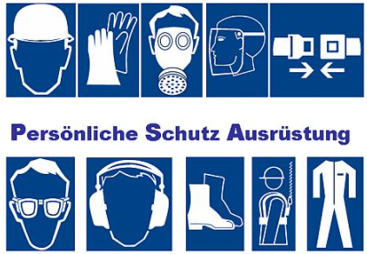 | The Contractor must provide its employees with suitable personal protective equipment. The Contractor and its employees are obliged to wear the personal protective equipment necessary for the work site concerned. Safety footwear is compulsory in production areas.
13.2 | When working on test benches, safety footwear, safety goggles and, if necessary, protective gloves must  be worn. Before starting such work, written permission (permit) must be obtained through the outside-contractor coordinator.

In-plant traffic – cranes – lifts (elevators)
14.1     | The rules for vehicular traffic within our plants are analogous with the German Highway Code (Strassenverkehrsordnung). The speed limit indicated on the factory grounds is to be observed. Vehicles given permission to enter are to be parked in the allotted parking spaces. Private vehicles must not be parked on company premises. Vehicles disregarding the rules or doing so on more than one occasion will be refused entry.
14.2   | Vehicles that form part of the traffic within the plant including cranes and aerial platforms may only be driven/operated by persons contracted in writing to do so by the Contractor. They must have been suitably trained and proven their ability to drive the vehicle concerned. The relevant driving licences must be carried at all times and produced for inspection on request.  Riding as a passenger on vehicles without passenger seats is prohibited.
14.3  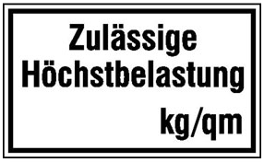   | When driving stacker trucks inside buildings the load-bearing capacity of the floor in the factory shed concerned is to be taken into account. That information is indicated on the weight limit signs at the external doors of the sheds. In the case of other vehicles such as aerial work platforms, the maximum load-bearing capacity of the floor should be obtained from the outside-contractor coordinator and observed (caution: uneven wheel loads with articulated telescopic platforms).  Driving cars or lorries inside buildings is not allowed (exceptions to be agreed with the outs ide-contractor coordinator). The maximum speed limit within buildings is 10 kph.
14.4  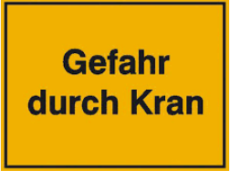 | When working within the operating range of cranes, the outside-contractor coordinator must be informed about the nature and scope of the work being carried out. He/she will approve the work to be carried out. Any such work may only be started following securing of the work site in consultation with the relevant specialist department (e.g. locking of the crane master switch, mechanical stops).

14.5   | All passenger lifts are equipped with an intercom connected to the permanently staffed Security Control Room. In the event of an emergency, the alarm button must be pressed for at least 3 seconds. The Security Control Room staff will then issue instructions on what to do and the subsequent procedure. Passenger lifts without lift cage doors are equipped with a safety photo-electric beam to prevent crushing or trapping of persons or goods.

Questions about health and safety/environmental protection
If the Contractor has any questions about health and safety or environmental protection, information
can be obtained from the HSE Department through the outside-contractor coordinator. Any such information shall not absolve the Contractor of its own responsibilities as enshrined in the statutory regulations.

Data protection and information security
When working on our premises, the Contractor or its employees may have access to sensitive company data or confidential personal information. Therefore, it is strictly prohibited for the Contractor or its employees to look inside cupboards and containers, written documents, files, books, card files, lists or drawings and plans. Should the Contractor or its employees nevertheless gain knowledge relating to the Client's business concerns or personal data, that information is to be treated in the strictest confidence. On no account whatsoever is the Contractor permitted to take possession of any data/information storage medium of any kind.
If the above obligations are breached, the Contractor and the employee(s) breaching the obligations shall be liable for compensation to the contracting company and the persons affected.
Access to areas secured with access terminals is only permitted with the agreement of the outside-contractor coordinator. Breaches may result in exclusion from contract awards.
Information regarding data protection and information security can be obtained through the outside-contractor coordinator.

Non-compliance with these requirements
In the event of contravention of these requirements we shall be entitled to order immediate expulsion from the factory grounds and permanent exclusion from the premises. Furthermore, we also reserve the right in such cases to take further action such as:
- termination of the contract with immediate effect
- claiming further redress.

Subject of the agreement
The Contractor carries out a variety of work on behalf of Rolls-Royce Solutions Augsburg GmbH. In doing so, it has access to the business premises of Rolls-Royce Solutions Augsburg GmbH. The personnel employed is to be made aware of the following aspects of this Data Protection Agreement.
The subject of the contractual relationship is a separately awarded contract.

That contract award also encompasses access to the offices and business premises of Rolls-Royce Solutions Augsburg GmbH and the disposal of paper waste, other documents and files. In order to dispose of larger files and folders in particular, the employee concerned may be given a key to the relevant document waste bin. The scope of the work must, however, be explicitly specified in the contract for work.
The Contractor shall once again explicitly draw the attention of employees who are given a key to the document waste bin for the purposes of disposing of larger files and folders to the importance of confidentiality and application of the two-heads principle when opening the bin.
The Contractor shall indemnify the Client against any and all compensation claims brought against the Client to the extent that such claims are based on a breach of the confidentiality obligations for which the Contractor, one of its employees or one of its agents is responsible. All confidentiality obligations shall continue in force even after termination of the contractual relationship.

Revised: June 2021

Publisher: Rolls-Royce Solutions Augsburg GmbH
Specialist department: HSE


Appendix 1 (Confirmation of Safety and Security Requirements for Outside Contractors)
(To be returned to Rolls-Royce Solutions Augsburg GmbH with the order acceptance confirmation by the outside contractor)

Confirmation of Safety and Security Requirements for Outside Contractors by the Contractor

As Contractors for work and/or services at Rolls-Royce Solutions Augsburg GmbH we hereby confirm that we acknowledge and understand the contents of these Safety and Security Requirements for Outside Contractors.
We hereby undertake to instruct all of our employees – including subcontractors – working at Rolls-Royce Solutions Augsburg GmbH of the contents of these Rules for Outside Contractors and to require them to implement the same.

Where additional requirements are imposed by verbal instructions by Rolls-Royce Solutions Augsburg GmbH to responsibility holders employed by us, we hereby undertake to pass such instructions on to all affected employees of ourselves and our subcontractors.
This confirmation shall remain valid for one year.

Company:

Date:

Name:

Signature:

Appendix 2 (Proof of Instruction)
(To be returned to Rolls-Royce Solutions Augsburg GmbH with the order acceptance confirmation by the outside contractor)

Proof of Instruction of Contractor's Contact Responsible

By signing below we hereby confirm that the contact responsible has been instructed regarding the rules of the "Safety and Security Requirements for Outside Contractors", will follow those rules and will instruct his/her staff accordingly and require them to follow those same rules.
Company:

Date:

Name:

Signature:

Instruction of employees by the outside contractor.
By signing below, the employees concerned hereby confirm that they have been instructed regarding the rules of the Rolls-Royce Solutions Augsburg GmbH Safety and Security Requirements for Outside Contractors and will follow the same.
This record sheet is to be returned to the outside-contractor coordinator of Rolls-Royce Solutions Augsburg GmbH completed and signed by all staff carrying out work on the premises of Rolls-Royce Solutions Augsburg GmbH. The instruction shall remain valid for one year.

No. | Print name | Date | Signature
1
2
3
4
5
6
7
8
9
10

Appendix 3 (Our Life-saving Rules)
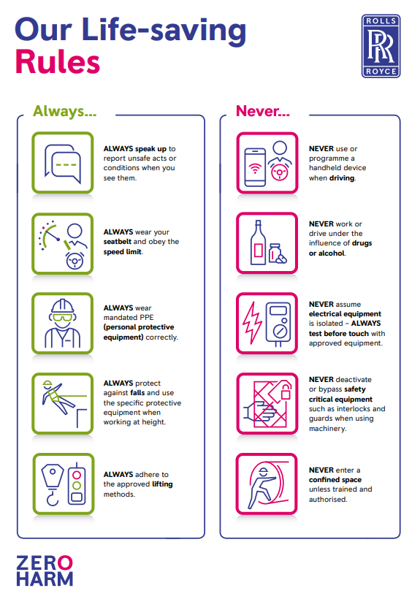

Appendix 4 (Questionnaire Prior to Accessing RRPS Company Grounds)
Questionnaire Prior to Accessing RRPS Company Grounds
for Visitors and Outside-contractor Staff
1. Have you or any of your staff returned from a high-risk area¹ abroad in the last 10 days?
¹The list of high-risk areas is updated daily on the website of the Robert-Koch-Institut (www.rki.de)

1a) High-risk area
A and/or B (high-incidence zone)?
3. Have you or any of your staff had direct contact with a person suffering from or a suspected case of Covid-19 in the last 14 days?

1b) High-risk area C (virus variant zone) and <10 days' quarantine?
Yes

When? _________
Yes
4. Have you and all of your staff been free of the following symptoms for the last two days?
- High temperature > 37.3°C (without temperature-reducing medication)
- Fatigue
- Runny nose
- Lost of sense of taste and/or smell – even without cold symptoms
- Cough/sore throat/itchy throat
- Shortness of breath
Other possible symptoms:
- Muscular pain/headache/dizziness
- Diarrhoea, nausea, vomiting, stomach pains
- Skin rash
- Inflammation of connective tissue
- Enlarged lymph nodes

2. Has a negative PCR or antigen test result** been obtained?

Entry allowed

* Details of exemptions from the quarantine requirements can be obtained from the relevant current version of the Baden-Württemberg Quarantine Regulations.
** The test must have been carried out no sooner than 5 days after the date of entry to Germany. The date of entry does not count as one of the 5 days. The test result must not be more than 72 hours old.

Yes
No
No
Yes
Entry allowed

No entry

Confirmation by Outside Contractor
(Questionnaire to be completed by Contractor's employee responsible for the site/trade)

- I have read and understood the questions and confirm that my answers are true and correct.

- I confirm that all of my staff working on Rolls-Royce Power Systems premises satisfy the requirements set out above and have understood the questions.

- I am aware that these requirements are applicable to all of my staff until further notice. I undertake to ensure that the requirements are also satisfied in the case of new staff.

- If any signs of illness should occur, I hereby undertake to notify my contact:

- Name: _____________________ on 0821/7480-____ .

Augsburg, date:

Company & name (legible): Signature:

Confirmation by Visitor

- I have read and understood the questions and confirm that my answers are true and correct.

- If any signs of illness should occur, I hereby undertake to notify my contact:
- Name: _____________________ on 0821/7480-____ .

Augsburg, date:

Company & name (legible): Signature:

